

**Science Knowledge Organiser**

Electricity

Year 6

Summary Statement

In this unit you will build on your work on electricity in year 4. You will construct simple series circuits and know what happens when you try different components, for example, switches, bulbs, buzzers and motors. You will learn how to represent a simple circuit in a diagram using symbols.

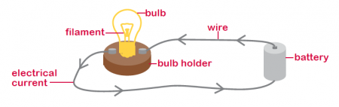

**By the end of the unit children can:**

* associate the brightness of a lamp or the volume of a buzzer with the number and voltage of cells used in the circuit.
* compare and give reasons for variations in how components function, including the brightness of bulbs, the loudness of buzzers and the on/off position of switches.
* use recognised symbols when representing a simple circuit in a diagram.

|  |
| --- |
| **Key Knowledge** |
| Electric components are the different parts which make up a electrical circuits. Some common electrical components include; **switches, bulbs, buzzers, motors, cells and wires.**  Electrical cells produce a flow of electrons **(current)** through the reaction of 2 chemicals inside them.  One measure of the power of a cell is **voltage (V**). When connecting cells in series their voltages are added together.  **Changing variables**  The bulb will get brighter if you increase the number of cells in the circuit.  The bulb will get dimmer as you increase their number in a circuit.  The direction of the motor changes if you swap how the wires are attached to it.  A buzzer will get louder if you increase the number of cells in a circuit.  A buzzer will get quieter if you add another buzzer or a bulb to the circuit.  If a switch is open, the circuit is not complete and the bulb will not light nor will the buzzer sound nor motor move. |

|  |  |
| --- | --- |
| **Key Vocabulary** | |
| **Spelling** | **Definition** |
| circuit | A complete route which an electric current can flow aorund |
| current | A flow of electricity through a wire or circuit |
| switch | A device for making and breaking the connection in an electric circuit. |
| voltage | An electrical force that is measured in volts. |
| volt | a unit used to measure the force of an electric current |

Components (parts of an electrical circuit)

