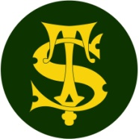

**Science Knowledge Organiser**

Year 6

Animals including humans

Summary Statement

**The circulatory system is made up of the heart, blood and blood vessels. It is the body’s delivery system and moves oxygen and nutrients to different parts of the body and takes waste products such as carbon dioxide away.**

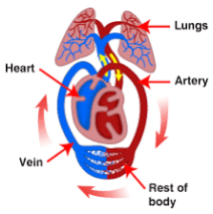

**By the end of the unit children can:**

● identify and name the main parts of the human circulatory system, and describe the functions of the heart, blood vessels and blood.

● describe the ways in which nutrients and water are transported within animals, including humans.

|  |
| --- |
| **Key Knowledge** |
| Circulatory System  All animals, including humans, have a circulatory system.  The heart pumps blood and keeps it flowing in the circulatory system. It sends oxygenated blood to every cell before returning to the heart. The heart then sends the deoxygenated blood to the lungs to pick up more oxygen.  Your heart never stops pumping blood whilst you are alive.  Your pulse tells you how fast your heart is pumping.  Blood  Blood helps oxygen get around your body. It also delivers nutrients and water to the different parts of your body and then carries waste such as carbon dioxide away. Blood also protects the body against infection. Your blood is ALWAYS red in colour.  It is made up of 4 main component: plasma, red blood cells, white blood cells and platelets.  Water  Our bodies use water in all its cells, organ and tissues to help regulate its temperature and maintain other bodily functions. |

|  |  |
| --- | --- |
| **Key Vocabulary** | |
| **Spelling** | **Definition** |
| Heart | An organ in the body that pumps blood. It is the size of your fist and is found slightly to the left of your chest. |
| Lungs | A pair of organs in the body which allow us to breathe in oxygen and breathe out carbon dioxide. |
| Blood | A red liquid that moves through blood vessels to different parts of the body. |
| Blood vessels | A series of tubes in the body which move blood around. They are either arteries or veins. |
| Arteries | A set of tubes in the body that take blood AWAY from the heart. |
| Veins | A set of tubes in the body that take blood TOWARDS the heart. |
| Aorta | The largest artery in the body. |
| Circulation | The movement of blood through the vessels. |

