

**Science Knowledge Organiser**

**Year 5**

**Living things and their habitats and Animals including humans**

Summary Statement

Many plants reproduce (make new plants) when the female seed is combined (fertilised) by the male sex cell called pollen. Many animals reproduce when the female egg is combined (fertilised) by the male sex cell called sperm. Some plants and more rarely some animals reproduce asexually – without the need for male and female parts to combine together.

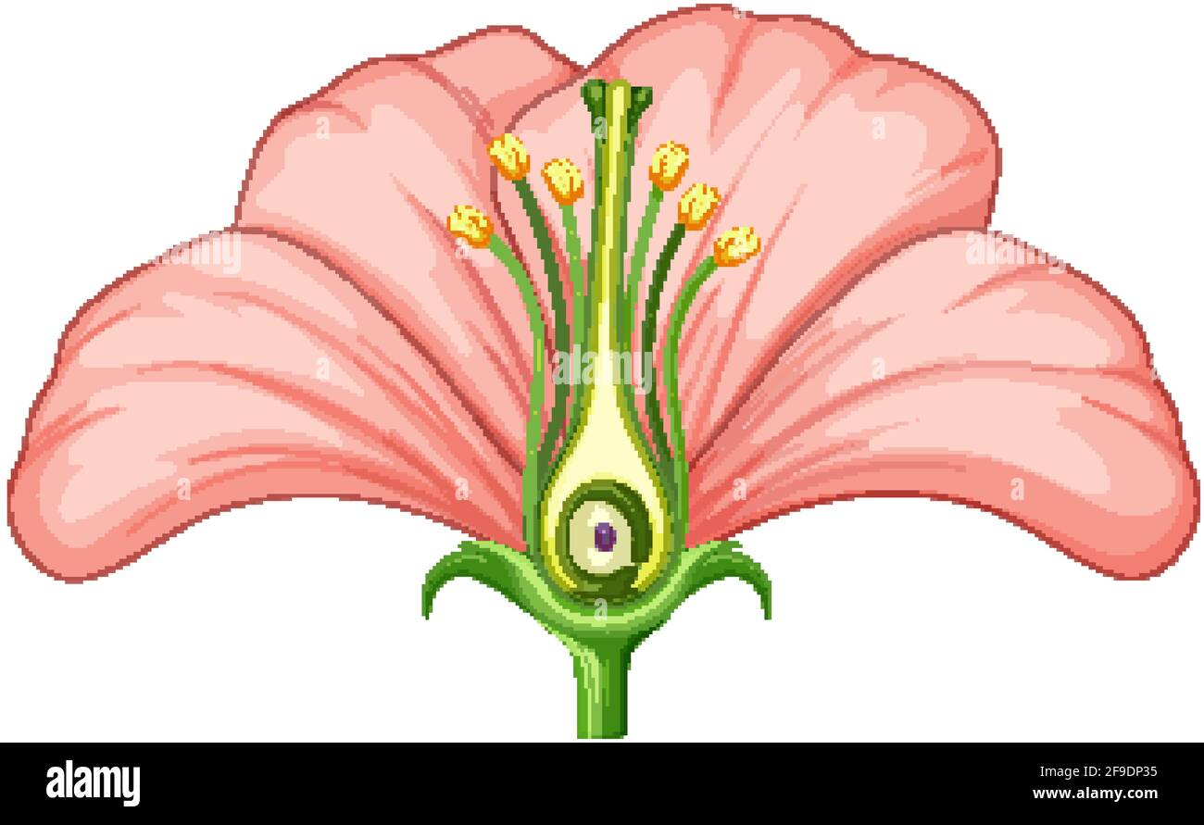

**By the end of the unit children can:**

* describe the differences in the life cycles of a mammal, an amphibian, an insect and a bird.
* describe the life process of reproduction in some plants and animals.
* Describe the changes as humans develop to old age.

|  |  |
| --- | --- |
| **Key Vocabulary** | |
| **Spelling** | **Definition** |
| Life Cycle | The life cycle of a plant or animal is the progression from its formation to its death, with all the changes this entails. |
| Sexual reproduction | The production of new living organisms where sperm from the male **fertilises** the female’s egg. |
| Asexual reproduction | Reproducing without fertilisation. |
| Pollination | The transfer of pollen to a stigma, ovule, flower or plant to allow fertilisation. |
| Fertilisation | Fertilised egg becomes a seed. |
| Sperm | The male reproductive cell. |
| Puberty | When an animal reaches sexual maturity. |
| Genitals | A person or animals external organs of reproduction. In females this is called a vagina. In males this is called a penis. |
| Vagina | The passage leading from the uterus to the opening through which a baby is conceived and born. |
| Period | The part of the menstrual cycle where a woman bleeds out of her vagina for a few days. |
| Penis | The male genital organ for the transfer of sperm. |
| Testicles | Two oval organs that hang below the penis that produce sperm. |

|  |
| --- |
| **Key Knowledge** |
| * When a flower is pollinated, a pollen grain sticks to the stigma. It then travels down the ovary. In the ovary , the pollen joins with the ovules and the ovules produce seeds. This is called fertilisation. * Some plants can reproduce (create new plants) from using different parts of the parent plant rather than producing seeds. This is called asexual reproduction * All amphibious animals and most insect reproduction is sexual reproduction, requiring two animals, one male and one female. * All mammals (including humans) and all birds reproduce by sexual reproduction – from the male fertilises the female’s egg inside her body. * I know that mammals give birth to live young and that most insects, amphibians, birds, fish and reptiles lay eggs. * Know the stages of the human life cycle and compare this to other mammals. * When humans reach sexual maturity we call this stage of the life cycle puberty. * Know the main changes that happen as a girl changes to an adult female during puberty. * Know the main changes that happen as a boy changes to an adult male during puberty. |

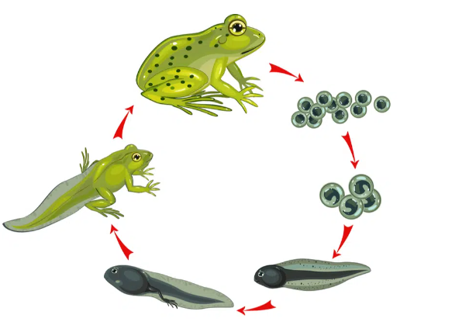

Life Cycle of an amphibian (Frog)