

**Science Knowledge Organiser**

**Year 4**

**Sound**

Summary Statement

Pupils identify how sounds are made and recognise that vibrations from sounds travel through a medium to the ear.

Sounds are made when objects vibrate. The vibration makes the air around vibrate, and the air vibrations enter your ear. Our brain hears the vibrations and turns this into a sound.

**By the end of the unit children can:**

* Identify how sounds are made, associating some of them with something vibrating.
* Recognise that vibrations from sounds travel through a medium to the ear.
* Find patterns between the pitch of a sound and features of the object that produced it.
* Find patterns between the volume of a sound and the strength of the vibrations that produced it.
* Recognise that sounds get fainter as the distance from the sound source increases.

|  |  |
| --- | --- |
| **Key Vocabulary** | |
| **Spelling** | **Definition** |
| Pitch | How high or low a sound is. |
| Vibration | A rapid shaking motion. |
| Decibels (dB) | A unit used to measure the intensity of a sound |
| Volume | How loud or quiet a sound is. |
| Sound source | Where a sound is coming from. |

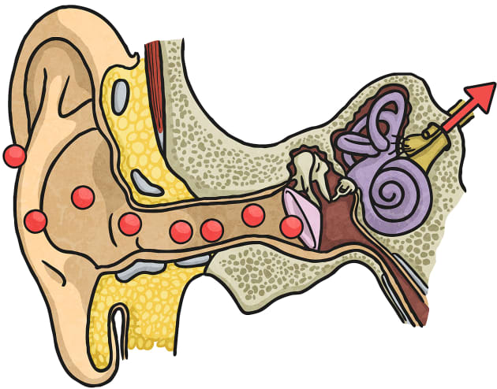

|  |
| --- |
| **Key Knowledge** |
| * A sound can travel through a solid, liquid or gas, from the sound source to our ears. * Sound travels in waves. The waves are caused by sound particles bumping into each other. * When the vibrations reach our ears they cause our ear drums to vibrate which allows us to hear sound. * The stronger the vibrations, the louder the sound. The weaker the vibrations, the quieter the sound. * Sound travels in all directions from a sound source. * Sounds decrease in volume as you move away from the sound source.. * As sound travels, the vibrations become weaker because they run out of energy, so the volume will decrease the further away you are from the sound source. |

