

**Science Knowledge Organiser**

Year 4

States of Matter

Summary Statement

Solids, liquids and gases can be classified according to their properties. We will explore how water changes state, exploring melting, freezing, condensing as well as a particular focus on evaporation. Finally, we will learn about the stages of the water cycle.

**By the end of the unit children can:**

* Compare and group materials together, according to whether they are solids, liquids or gases.
* Observe that some materials change state when they are heated or cooled, and measure or research the temperature at which this happens in degrees Celsius (°C)
* Identify the part played by evaporation and condensation in the water cycle and associate the rate of evaporation with temperature.

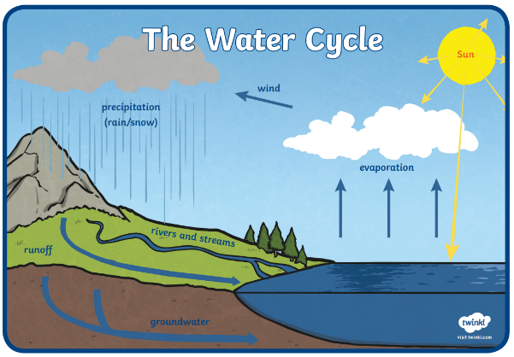

|  |
| --- |
| **Key Knowledge** |
| Matter can change from one state to another if it is heated or cooled. If water is frozen it causes ice to form (a solid) if heated it changes to water (a liquid). This change is called melting. If water is heated, it changes to steam (a gas). |
| The freezing point of water is 0°C.  The boiling point of water is 100°C |
| Increased temperatures speed up the rate of evaporation, while decreased temperatures slow down the process. |
| The water cycle is the complete journey that water makes, from one place to the other, and from one state to the other. As the word ‘cycle’ suggests, there is no starting point. This means that we can begin at any point and follow its path until it gets to where we started again. |

|  |  |
| --- | --- |
| **Key Vocabulary** | |
| **Spelling** | **Definition** |
| solid | A solid holds its shape and has a fixed volume. |
| liquid | A liquid fills up the shape of the bottom of a container. It forms a pool, not a pile and also has a fixed volume. |
| gas | A gas can escape from an unsealed container. It fills up the space it is in, and does not have a fixed volume |
| celsius | A scale of temperature on which water freezes at at 0° (and boils at 100°) under standard conditions |
| evaporation | Changing from a liquid to a gas. |
| condensation | Changing from a gas to a liquid. |
| variable | A variable is anything that can change and be measured in an investigation. |

