

**Science Knowledge Organiser**

**Year 3**

**Rocks Detectives**

Summary Statement

There are three main types of rocks: Metamorphic, Igneous, and Sedimentary. Scientists generally classify rocks by how they were made or formed.

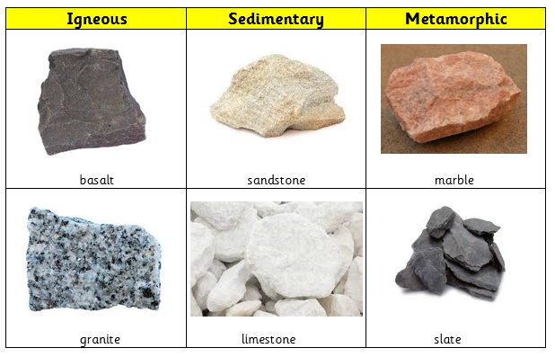

**By the end of the unit children can:**

* Compare and group together different kinds of rocks on the basis of their appearance and simple physical properties.
* Describe in simple terms how fossils are formed when things that have lived are trapped within rock.



|  |  |
| --- | --- |
| **Key Vocabulary** | |
| **Spelling** | **Definition** |
| Metamorphic rocks | rocks that have been changed at a chemical level due intense heat from magma. |
| Igneous rocks | rocks are formed from the heat of lava or magma. |
| Sedimentary rocks | rocks are formed from sediment being compressed |
| Permeable | A material that allows liquid or gas to pass through it. |
| Impermeable | A material that does not allow liquid or gas to pass through it. |
| Fossils | The hard remains of an animal or plant that re found inside a rock. |
| Sediment | Solid material that settles at the bottom of liquid. |
| Compact | To press something so it becomes more solid. |

|  |
| --- |
| **Key Knowledge** |
| Rocks   * There are three major types of rocks: **Metamorphic, Igneous** and **Sedimentary.** * **Metamorphic** rocks are formally i**gneous** and **sedimentary** rocks that have been changed at a chemical level due to intense heat from magma e.g. **marble, slate.** * **Sedimentary** rocks are formed from **sediment** (small pieces of rock from earth that settle at the bottom of liquid i.e. water) being compressed by the weight of the liquid above and cementing over time. They are made of small grain e.g. **limestone (chalk)** and **sandstone**. * **Igneous** rocks are formed from the heat of lava or magma. They have large crystals. e.g. **granite** and **basalt.** * Rocks can be grouped according to their appearance and properties. For example **slate** and **marble** are both hard rock; **sandstone** and **chalk** are considered soft rocks.   Fossils   * Know the sequence of **fossil** formation as –   1. Animal dies and is buried by sediment  2. Soft parts of the animal decay or decompose  3. More sediment build up around the animal and is compressed to form rock.  4. Bones start to be dissolved by water underground.  5. Minerals in the water then turn to rock. |

