

**Science Knowledge Organiser**

**Year 2**

**Plants: The Apprentice Gardener**

**Summary Statement:**

Pupils recap what plants need to grow healthily and the differences between bulbs and seeds. This unit includes an investigation about growing healthy plants.

**By the end of the unit children can:**

* Observe and describe how seeds and bulbs grow into mature plants.
* Find out and describe how plants need water, light and a suitable temperature to grow and stay healthy.

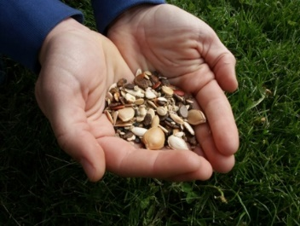

**bulbs**

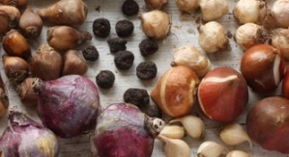

**seeds**

|  |  |
| --- | --- |
| **Key Vocabulary** | |
| **Spelling** | **Definition** |
| Life Cycle | A series of changes living things go through. |
| Seed | The part of the plant from which new plants grow. |
| Bulb | Part of a plant under the dirt that stores food while the plant is resting from growing. |
| Mature plant | A plant that is fully grown or has been growing for a long time. |
| Observations | Seeing and taking notice of something. |
| Germination | When the seed begins to grow. |

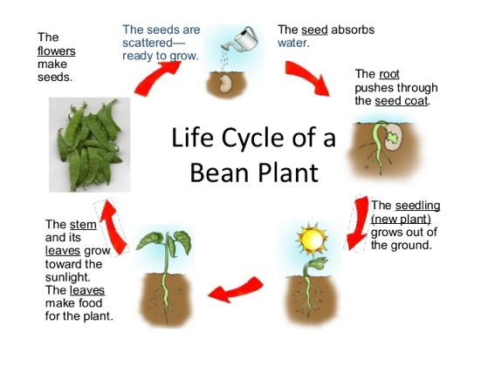

|  |  |
| --- | --- |
| **Key Knowledge** | |
| All plants go through a life cycle. A circle diagram is used to show that it is a continuous process. | |
| Seeds need the following to germinate:   * Water * Oxygen * Warmth | Plants needs the following to grow and be healthy (LAWNS):   * **L**ight * **A**ir * **W**ater * **N**utrients (‘food’ absorbed by the roots) * **S**pace |
| Healthy and unhealthy plants compared - Stock Image - C024/9334 - Science  Photo LibraryHealthy plants are green and strong but unhealthy plants are often pale, yellowy and weak. | |
| Plants grow from seeds and bulbs. Seeds are sown and bulbs are planted. They both have a store of food inside them. | |
| **Germination stages:** seed is planted 🡪 absorbs water and starts to grow 🡪 roots and shoots grow 🡪 stem and leaves grow 🡪 some may grow flowers and seeds 🡪 seeds are spread by animals, humans and wind and the process starts again. | |
| Roots always grow downwards to find more water. Shoots grow upwards to find light. | |