

**Science Knowledge Organiser**

**Year 2**

**Animals including Humans: Taking Care**

Summary Statement

Pupils study the life cycles and learn that animals, including humans, have offspring that grow into adults. New learning includes the basic needs of animals, including humans, for survival and the importance of exercise, eating the right amounts of different types of food, and hygiene.

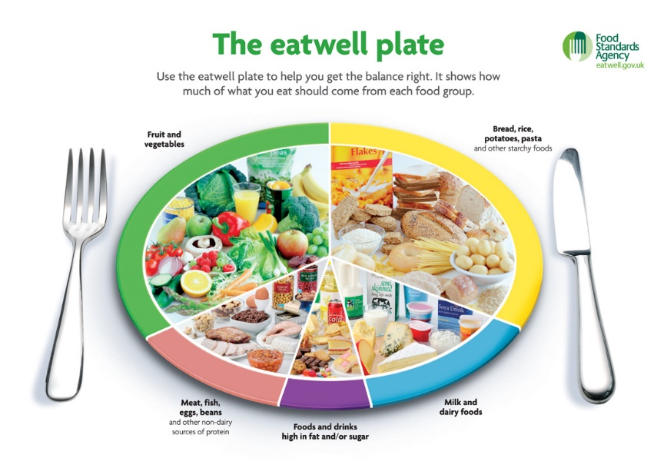

**By the end of the unit children can:**

* Find out about and describe the basic needs of animals, including humans, for survival (water, food, air).
* Describe the importance for humans of exercise, eating the right amounts of different types of food and good hygiene.
* Notice that animals, including humans, have offspring, which grow into adults.

|  |  |
| --- | --- |
| **Key Vocabulary** | |
| **Spelling** | Definition |
| Good hygiene | Staying clean to keep us healthy. |
| A balanced diet | Eating the right amount from each food group. |
| Classify | To group or order. |
| Exercise | Being physically active. |
| Pulse | The regular beating caused by your heart. |
| Offspring | A person or animal’s child or children. |
| Growth | The process of getting bigger. |
| Life cycle | Stages a living thing goes through in its life. |
| Survival | Continuing to live |

|  |
| --- |
| **Key Knowledge** |
| All animals have 3 basic needs for survival: water, food and air. |
| There are other things which are also important for humans and animals, including shelter and being healthy. |
| To stay healthy humans should:   * eat a balanced diet (the right amount of each food group and plenty of fluids), exercise regularly and have good hygiene. |
| Animals including humans have offspring which grow into adults. Growth in humans is as follows:  baby 🡪 toddler 🡪 child 🡪 teenager 🡪 adult |
| In humans and some animals, these offspring will be young, such as babies or kittens, that grow into adults. In other animals, such as chickens or insects, there may be eggs laid that hatch to young or other stages with then grow to adults. |
| Babies need water, food, air and shelter to stay alive. Although things like love, being kept clean, medical care etc. is important for health and well-being, they are not absolutely essential for a baby to survive. |
| Humans go through lots of changes in their lives, for example, being able to do a lot more on their own to look after themselves compared to when they were a baby. |

