

**Science Knowledge Organiser**

**Year 1**

**Everyday Materials**

Summary Statement

Many different materials make up the world around us, from natural materials like rocks and wood to manufactured materials such as plastic and paper. These materials have properties, some unique, which make them good for different jobs.

Key knowledge:

**By the end of the unit children can:**

* Distinguish between an object and the material from which it is made
* Identify and name a variety of everyday materials, including wood, plastic, glass, metal, water, rock, paper and fabric
* Describe the simple physical properties of a variety of everyday materials
* Compare and group together a variety of everyday materials on the basis of their simple physical properties

|  |  |  |
| --- | --- | --- |
| **Type of Material** | **Properties** | **Common examples** |
| Wood | hard, strong | Table, door |
| Plastic | strong, shiny, bendy | Bottles, pens |
| Glass | transparent, smooth | Windows, glass |
| Metal | hard, strong, shiny | Pan, scissors, knife |
| Water | runny, wet, transparent | Ice cubes |
| Rock/bricks | hard, strong | Buildings |
| Fabric  https://www.sundeala.co.uk/wp-content/uploads/2018/02/Fabric-3.png | soft, smooth, absorbent | Clothes, bedding  Brentwood Ursuline Convent High School - Brentwood Ursuline - P.E ...C:\Users\sale.r1\Local Settings\Temporary Internet Files\Content.MSO\7E89C5E6.tmp |
| Paper  stack-of-paper-png-paper-stack – Mark's Blog | smooth, opaque | Books, newspapers  C:\Users\sale.r1\Local Settings\Temporary Internet Files\Content.MSO\C7D2ED95.tmp |

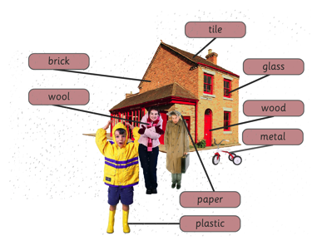

|  |  |
| --- | --- |
| **Key Vocabulary: Properties** | |
| **Spelling** | **Definition** |
| material | What something is made from |
| hard | Not easily broken |
| soft | Easy to cut, fold or change shape |
| shiny | Reflects light easily |
| dull | Not very bright or shiny |
| transparent | Something you can see through |
| opaque | Something you can’t see through |
| rough | Has an uneven surface |
| smooth | An even surface with no lumps or bumps |
| waterproof | Water can’t get through |
| bendy | Can be bent easily |

**Did you know..?**

A spider’s web is the strongest *natural* material ever known! It is ten times stronger than steel (a type of metal alloy).

