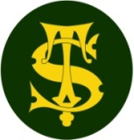

Summary Statement

* Children will use the eight points of a compass, four-figure grid references, symbols and keys to build their knowledge of the wider world through studying France. They will learn about the physical geography of France, including its mountains, rivers and biomes, as well as learning about transport and crops grown in France.

**Geography Knowledge Organiser**

**Year 4**

European country - France

|  |  |
| --- | --- |
| **Key Vocabulary** | |
| **Spelling** | **Definition** |
| Eurostar | A high-speed train (TGV - Train à Grande Vitesse) which goes under the channel tunnel from London to Paris. |
| Biome | A biome is a large group of ecosystems that can be on land and in water. It is an area with similar plants, animals and temperature. There are 4 biomes in France. |
| Mediterranean biome | This biome is generally characterized by dry summers and rainy winters, and is found in the Southeast of France by the Mediterranean Sea. |
| Temperate broadleaf | A biome that has many deciduous trees which drop their leaves in the fall. These forests are also known as broad-leaf forests because the trees have wide, flat leaves. This biome covers most of France. |
| Mountain forest | This biome is very cold, and is located at a high altitude, and is found in the Alps of France. |
| Alpine tundra | This biome is located on mountains throughout the world at high altitude where trees cannot grow. |

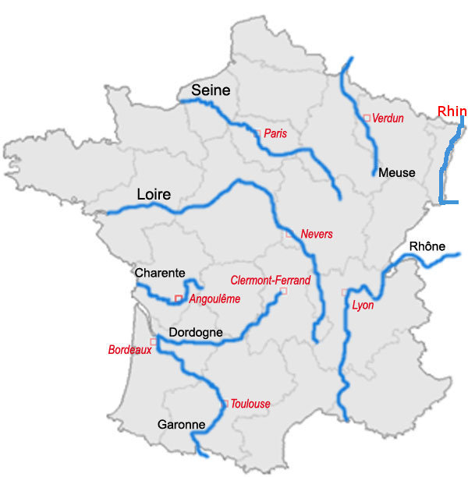

France is 550,000km2 and England is 130,000km2

The most efficient and environmentally friendly way to get to France is by Eurostar.

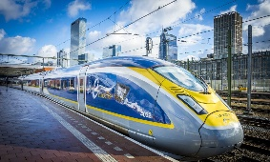

There are 7 rivers in France: Loire, Meuse, Seine, Rhone, Garonne, Dordogne, Charente.

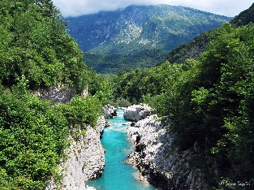

The main cities in France are: Paris, Nice, Lille, Bordeaux, Toulouse, Lyon, Marseille, Montpellier

Mountain ranges in France:

* Massif Central
* The Alps
* The Pyrenees

**Did you know..?**

The city of Bordeaux is famous for its wine and it produces 960 million bottles of wine a year!



