

**Geography Knowledge Organiser**

**Year 4**

How can we divide the world up?

Summary Statement

* Children will be able to use maps, atlases, globes and digital/computer mapping to locate countries and describe features studied and use the eight points of a compass.
* Children will be able to identify the position and significance of latitude, longitude, Equator, Northern Hemisphere, Southern Hemisphere, the Tropics of Cancer and Capricorn, Arctic and Antarctic Circle, the Prime/Greenwich Meridian and time zones (including day and night).

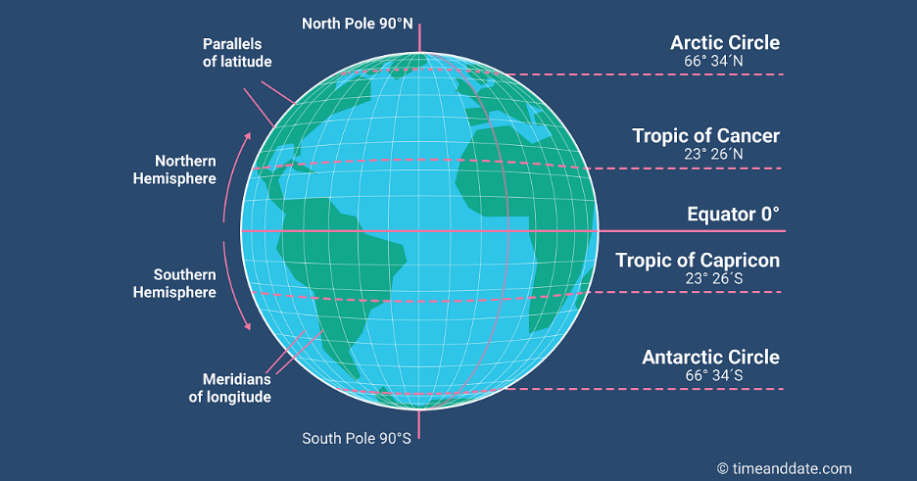

**Did you know..?**

Although the weather is generally hot, there is a mountain on the equator in South America where you can ski!

/

|  |  |
| --- | --- |
| **Key Vocabulary** | |
| **Spelling** | **Definition** |
| Equator | The imaginary line that divides the earth in half. |
| Northern hemisphere | The half of the globe above the equator. |
| Southern hemisphere | The half of the globe below the equator. |
| Tropics | Parts of the world that lie between two lines of latitude, the Tropic of Cancer, 23.5° north of the equator, and the Tropic of Capricorn, 23.5° south of the equator. The tropics have a humid climate, where the weather is hot and damp. |
| Latitude | The latitude of a place is its distance from the equator. Lines of latitude run from east → west. |
| Longitude | The longitude of a place is its distance to the west or east of a line passing through Greenwich. Lines of longitude run from north → south. |
| Prime/Greenwich Meridian Line | The prime meridian is the line of longitude, corresponding to zero degrees and passing through Greenwich, England, from which all the other lines of longitude are calculated. |
| Time zones | One of the areas into which the world is divided where the time is calculated as being a particular number of hours behind or ahead of GMT (Greenwich Mean Time). |



Time Zones

* The Prime Meridian (PM) line divides the earth into the eastern and western hemisphere.
* It passes though the Royal Observatory in Greenwich, England.
* All time zones start here - Greenwich Mean Time (GMT).
* There are 24 different time zones – one for each hour in the day.
* From GMT to the east = +1 hour for every time zone.
* From GMT to the west = -1 hour for every time zone.
* The International Date Line is on the opposite side of the world from the PM.
* When it is noon at the Prime Meridian, it is midnight along the International Date Line. This is where midnight occurs first across the globe.

