**Geography Knowledge Organiser**

**Year 3**

Biomes of the World

Summary Statement: Children will use maps, atlases, globes and digital mapping to locate countries and describe features studied and understand key aspects of physical geography, including: climate zones, biomes and vegetation belts.

|  |  |
| --- | --- |
| **Key Vocabulary** | |
| **Spelling** | **Definition** |
| Equator | A line that circles the Earth, separating it into the Northern and Southern Hemispheres. It is also the point on Earth that is always the closest to the sun. |
| Tropics | The region of Earth that is near to the equator. |
| Climate | The average measurements of temperature and weather over a period of time. |
| North Pole | The most northern point of the Earth. |
| South Pole | The most southern point of the Earth. |
| Natural Environment | It encompasses all living and non-living things that occur naturally on Earth. |
| Aquatic | A biome that is formed almost entirely by water and depends on water for life to grow. |
| Temperate Deciduous Forest | A biome that has many deciduous trees, which drop their leave in Autumn. They are also known as broad-leaf forests because the trees have wide, flat leaves. |
| Boreal/Taiga Forest | A large community of plant and animal life, living in a major natural habitat, such as a forest or lake. |
| Tundra | The coldest of biomes and a mainly treeless plain, where harsh conditions make it hard for plants and animals to survive. |

**By the end of the unit, children will be able to:**

* **Locate Chembakoli and understand its climate.**
* **Understand biomes and locate the position of biomes across the world.**
* **Understand which animals live in each biome.**

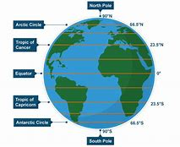

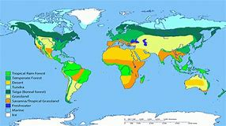

India

