**Geography Knowledge Organiser**

**Year 2**

Hot and Cold Places

Summary Statement

Children will learn about how the climate in countries change based on whether it is closer to the Equator or the North and South Poles.

**By the end of the unit, children will be able to:**

* Label a globe with the equator, the North Pole and the South Pole.
* Label a compass with North, South, East and West.
* Understand that the climate in the area surrounding the equator is at its hottest and these areas are called the tropics
* Know there is a gradual fall in temperature the further away from the equator. It is the coldest at the North and South Poles.
* Recognise that animals adapt to their environment in hot or cold countries.
* Locate where animals would come from based on their knowledge of how countries are either hot or cold based on their location to the equator.
* Understand how a camel has adapted to countries with desert and how penguins have adapted to cold countries.

|  |  |
| --- | --- |
| **Key Vocabulary** | |
| **Spelling** | **Definition** |
| continent | A large block of land and any surrounding islands. |
| countries | A large area of land, within a continent. |
| equator | An imaginary line around the middle of the Earth. The climate around it is known as the tropics and is very hot. |
| poles | There is the North pole at the top of the globe and the South pole at the bottom of the globe. It is very cold at the poles. |
| climate | This is like the weather, but is looked at over a long amount of time. |
| adaptations | A natural process where plants and animals change over a long period of time to fit their environment. |
| weather | The daily state of the air around us, e.g. cold, windy, sunny, rainy. |
| position | In a specific place. |
| globe | A sphere shape model of the Earth. |

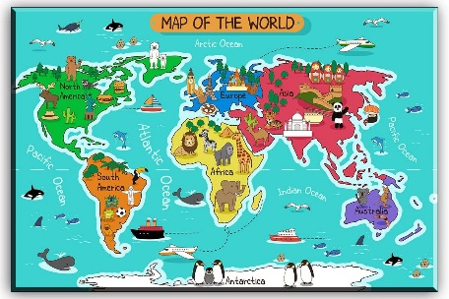

**Did you know?**

Penguins have feathers to trap the warmth and have fat to protect against the cold.

**N**ever **E**at **S**hredded **W**heat

North East

South West

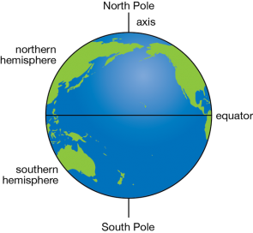

**Did you know?**

Camels are covered in fur to protect themselves from sunburn and have humps to store fat.