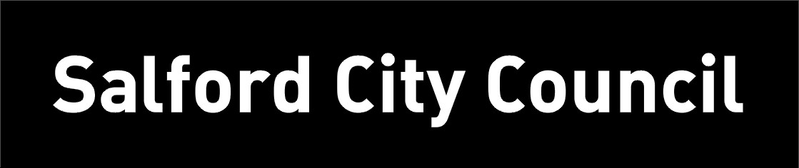
PARK RISK ASSESSMENT DATE RISK ASSESSMENT PREPARED: 13th March 2016
ACTVITY: |  | Design and Technology
VENUE : STOC
RISK ASSESSMNET OF: Utility snips (and safety snips)

LOCTION OF ACTIVITY: CLASSROOMS- closely supervised by an adult.

HAZARDS | CONTROL MEASURES |  | ADDITIONAL INFORMATION
Utility snips blade | - Avoid injury by choosing tools appropriate to task and appropriate to the age and experience of the user.  - Snips are only to be used when the material to be cut is too thick for other types of scissors.  - Pupils to be made aware of which thicker sheet materials can be cut effectively with utility snips.  - Children to be made aware that the snips are far more powerful than ordinary scissors.  - Children to be made aware that the blades are sharp and could cause a pinching cut.  - Children who are likely to cause injury to themselves or others are prohibited from using utility snips.  - All activities using utility snips to be supervised.  - Left-handed pupils and those who find utility snips difficult to use should use safety snips instead. |  | - Utility and multi-purpose tin snips can cut a variety of materials, and are not designed specifically for sheet metal.  - As well as cutting light metals such as aluminium and copper, these tin snips can be used for cutting various other materials.  - Utility snips often have cushioned grip handles to add comfort during use.  - Utility and multi-purpose tin snips are spring-loaded to aid the user in cutting tough materials and make the job easier.  - The spring makes the handles move back into place when force is released to allow for a smooth and continuous cutting motion.
Children and staff to be read the risk assessment before using the utility snips.

Safety snips, utility snips
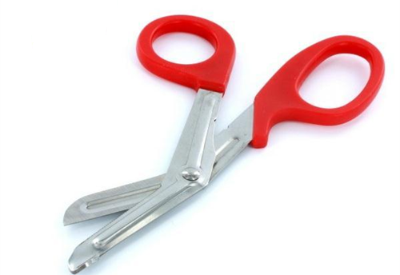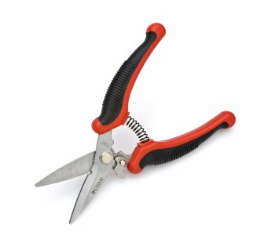

RISK ASSESSMENT PREPARED BY: Tracy Robinson
NAME OF SCHOOL: St. Thomas of Canterbury RC Primary

