
PARK RISK ASSESSMENT DATE RISK ASSESSMENT PREPARED: 13th March 2016
ACTVITY: |  | Design and Technology
VENUE : STOC
RISK ASSESSMNET OF: Pinking shears

LOCTION OF ACTIVITY: CLASSROOMS.

HAZARDS | CONTROL MEASURES |  | ADDITIONAL INFORMATION
Pinking shears blades | - Avoid injury by choosing tools appropriate to task and appropriate to the age and experience of the user.  - Pinking shears to be used to cut paper, card and thin fabric such as cotton and felt.  - Children to be made aware that the blades are sharp and could cause a pinching cut.  - Children who are likely to cause injury to themselves or others are prohibited from using pinking shears.  - All activities using pinking shears to be supervised.  - Pupils to be taught how to carry pinking shears- blades closed and held in a gripped palm, never carried with blades pointing outwards. |  | - Pinking shears are scissors, the blades of which are saw-toothed instead of straight. They leave a zigzag pattern instead of a straight edge.  - Pinking shears have a utilitarian function for cutting woven cloth. Cloth edges that are unfinished will easily fray, the weave becoming undone and threads pulling out easily. Pinking shears help stop fraying.
Children and staff to be read the risk assessment before using the pinking shears.
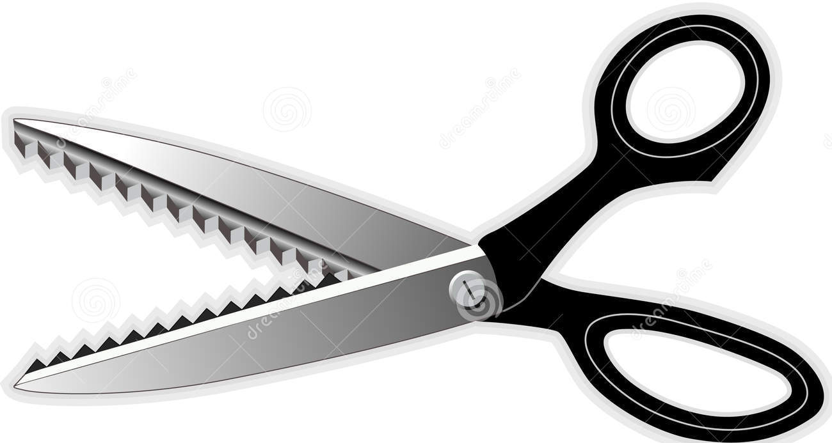

RISK ASSESSMENT PREPARED BY: Tracy Robinson
NAME OF SCHOOL: St. Thomas of Canterbury RC Primary

